Lab 2: Containerization & Kubernetes Orchestrations

LAB SECTION 1: DOCKER STORAGE
- Loss of Container-Layer Data after Container Deletion

Step 1: Start an ephemeral container named c1-ephemeral

Step 2: Create a file inside the container's writable layer and verify content.

Step 3: Delete the container forcefully.

Step 4: Start a new container c2-ephemeral from the same image and attempt to read the file.

- Permanent Storage Demonstration
- Permanent Storage Using Docker Named Volume

Step 1: Create a managed Docker named volume.
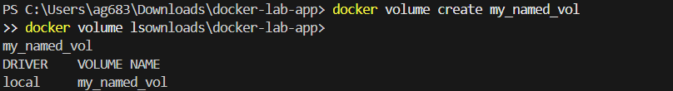

Step 2: Run container c-vol-writer attaching my_named_vol to /app/storage and write persistent data.

Step 3: Delete c-vol-writer completely.

Step 4: Start an entirely new container c-vol-reader mounting the same volume and verify data persistence.

- Permanent Storage Using Docker Bind Mount

Step 1: Create a host directory and initial host file.
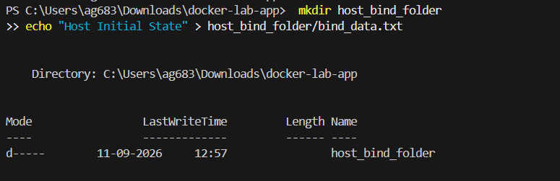

Step 2: Run container c-bind-mount mapping host folder to container path /mnt/data.

Step 3: Remove container c-bind-mount and verify updated contents on host filesystem.
